|  |  |  |
| --- | --- | --- |
| FOW 12 | English *Globalization* | 2022-04-01 |

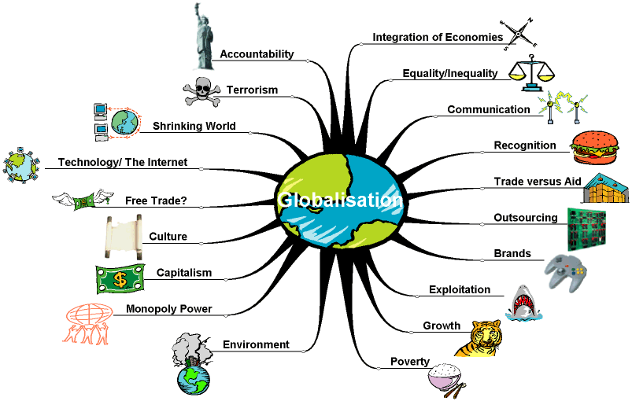

**Task:**

There are many different aspects of globalization. Choose at least two of them and find some information.

As your final exam comes closer, you create a worksheet in which you specialize on your chosen aspects.

For your class you create a worksheet with at least two tasks. One of them should be a **reading comprehension** task, a **cartoon analysis**, a **mediation** task, a **comment** or a **discussion**.  
The second task is your free choice.

If you don’t finish the task in this lesson, you have to finish it at home and hand it in the next lesson the latest!