|  |  |  |
| --- | --- | --- |
| FOW 12 | Cartoon Analysis  Environment | ___.___.20___ |

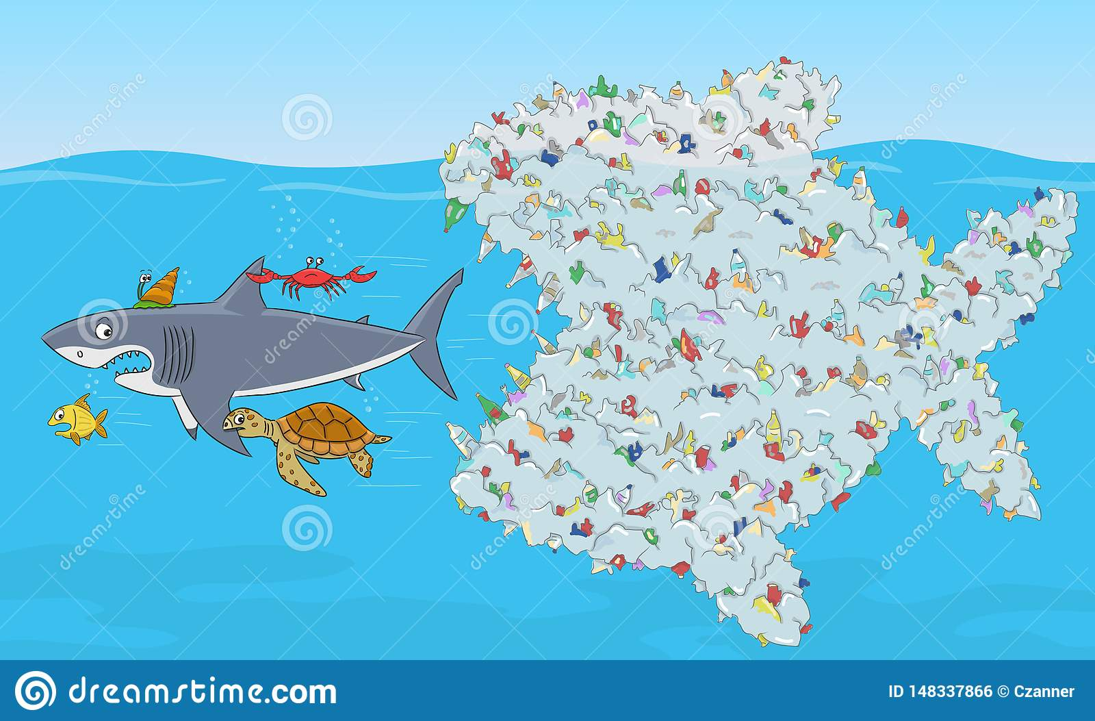

**Assignment:** Please describe and analyze the cartoon.