|  |  |  |
| --- | --- | --- |
| **FO G/T/W 21 GTA 21** | **BBS Neustadt a. Rbge.** | **Name:** |
| **15.05.2023** | **Abschlussprüfung Englisch** | **Vorschlag B** |

**I. Reception - Reading Comprehension (30%)  
Read the blog on effective advertising and tick the correct statements.**

## **What is Effective Advertising?**

(…) Every business will advertise at some point. Effective advertising will help gain awareness of your business and let people know what you have to offer. Advertising is essential for any business as it will help you compete with other similar companies, raise brand awareness, and increase sales. Without effective advertising, you risk not being as recognizable as your competitors, and in turn, having less success.  
With that being said, effective advertising is going to be advertising that you do for your business or company that you see a positive turnover for. After an ad campaign ends, you want to have earned more than you spent on the campaign. This is how you know the advertisement was successful. If your ad campaign ends and your company lost money over that time, that means the campaign was not successful and you should re-evaluate how you advertise in the future.

## **Why Is Advertising so Important to Business?**

(…) Advertising is a vital part of any business, brand, company, school, and more. You don’t have to be selling a product to benefit from effective advertising. Advertisements are also used to announce events or things like movies or tv shows. Advertising’s main goal is to gain attention to whatever the ad is for.  
Now more than ever it’s easier to advertise to a wide group of people. Before, advertisements were mainly limited to TV, radio, billboards, magazines/newspapers, etc. While those are all still [**valid forms of advertising**](https://featherflagnation.com/blog/?p=17022&preview=true), there are even more choices out there thanks to the digital age. It’s becoming easier to do ad campaigns throughout platforms such as Youtube, podcasts, social media, Twitch, and more.   
While there are more and more ways to advertise your business, company, or store, that also means there is more and more competition out there. This should encourage you to advertise even more than you already are. The more platforms you advertise on, the higher chance you have of gaining new traction to your store or website. Remember, it doesn’t always have to be about selling a product but can also be about raising awareness*.*  
When it comes to effective advertising for your business, you can choose to hire an ad agency, or you can do the advertisement yourself. If your business has a dedicated marketing team, they should be able to come up with fun, creative ads that will help bring in new customers.

## **Promotion of Products and Services**

A big reason companies choose to advertise is to promote a product or sale that they’re offering. If your business has a new item, a special sale, clearing inventory, a new location, etc, you should run an ad campaign to help bring awareness to you. How are potential customers going to know you have a new sale if you don’t showcase it anywhere but inside your store?   
An easy way to spread a message is by using social media. Most companies these days have some form of social media presence, whether that’s Facebook, Twitter, Instagram, Pinterest, YouTube, etc. Whatever social media platform your business uses, you should always keep it up to date with any new products or sales you have.

|  |  |  |
| --- | --- | --- |
| **FO G/T/W 21 GTA 21** | **BBS Neustadt a. Rbge.** | **Name:** |
| **15.05.2023** | **Abschlussprüfung Englisch** | **Vorschlag B** |

(…)   
If you’re using effective advertising, you should see a turnaround on the product you’re advertising for. If you sell a service, you should see more inquiries about your services and a positive turnover, although it may not be as immediate. A good way to measure the success of an ad is by monitoring the increase in sales, foot traffic, and website hits. This will help you see patterns and determine the success of your ad.  
You don’t only have to advertise a product or service, though. You can also sponsor events such as sporting events, festivals, carnivals, and more. This is referred to as indirect advertising and is popular with bigger companies such as [**Nike**](https://www.nike.com/)**.** Think about red carpet events, stadiums, festivals, etc. that have [step and repeat banners](https://featherflagnation.com/product/custom-step-and-repeat/)or [**flags**](https://featherflagnation.com/custom-flags/) showing the logo of the sponsors. This is a great way to have your business be seen by a variety of new (and maybe old) customers that may not have been aware of your business beforehand! (…)  
  
**Affordable Types of Advertising**There is a multitude of ways you can choose from to advertise effectively for your business. The top 10 most common forms of advertising are display ads, social media ads, newspapers/magazines, [*outdoor advertising*](https://featherflagnation.com/)***,***radio & podcasts, direct mail & personal sales, video ads, product placement, event marketing, *and*email marketing.  
While all of the above are examples of effective advertising, not every one of those examples will work for your business. Some forms of effective advertising are more expensive than others. It’s important to do your research and see what kind of ad would work best for you and your business.

Social media ads and [**outdoor signage**](https://featherflagnation.com/) are some of the easiest, and most cost-efficient advertising you can do.

Social media advertising is easy and a great way to advertise your services online. With social media ads, you get to create the image and write a caption that you think will draw people in. And, once you have the ad done, you can use it for multiple platforms! One of the best advantages social media ads have over other forms of online advertising is the cost can be controlled easily by you!

 A lot of platforms, like [**Facebook**](https://www.facebook.com/FeatherFlagNation/)or [Instagram](https://www.instagram.com/featherflagnation/)**,**will allow you to set a budget for your ad. This is great because you don’t have to worry about being overcharged! Set your price, upload the ad, and the platforms will showcase your ad within the price perimeters you give. Sometimes you can even get a starting credit on your first ad, saving you even more!

[**Outdoor signage**](https://featherflagnation.com/)is another great and affordable way to advertise for your business. An obvious form of outdoor advertising that comes to mind may be a billboard. Billboards are great as they’re seen by hundreds to thousands of people a day, but they can become pretty cost-heavy after a while. Most billboard companies charge a monthly fee that can be anywhere from $750 up to $15,000 a month depending on where the billboard is located and whether or not it’s a digital or physical billboard.

Even at the lower range of $750, that can add up after a few months and you may not see a return on profit. (…)

*Source:* [*http://featherflag*](http://featherflag)*nation.com/blog/what-is-effective-advertising/*

|  |  |  |
| --- | --- | --- |
| **FO G/T/W 21 GTA 21** | **BBS Neustadt a. Rbge.** | **Name:** |
| **15.05.2023** | **Abschlussprüfung Englisch** | **Vorschlag B** |

Effective advertising…

□ … is used by every company.

□ …informs your customers about your products and services.

□ …helps to hold up with your competitors.

□ …has more than one effect for your company.

Without effective advertising…

□ …your company isn’t successful.

□ …you will have a negative turnover.

□ …you might pay more for the campaign than you earn.

□ …you could lose money.

□ Advertising can be used by companies as well as by other institutions.

□ If you want to get attention for a new movie you should place an advert on a TV show.

□ By using advertising you can get people’s attention for different kind of events.

□ Advertising is not only made for products.

□ It is easier today to reach a bigger target group than it used to be.

□ TV and radio spots aren’t successful forms of advertising anymore.

□ Today you better place your adverts on social media platforms or YouTube.

□ Billboards are out of fashion today.

□ Effective advertising can better be designed by ad agencies.

□ Marketing teams are old fashioned.

□ In your company could be a creative team designing good ads.

□ Good spots make more people interested in products or services.

□ Effective advertising usually increases the turnover of a company.

□ A rise of inquiries can directly be related to effective advertising.

□ Monitoring helps to find out about the effect of advertising.

□ Different figures can show how successful an advertising campaign is.

|  |  |  |
| --- | --- | --- |
| **FO G/T/W 21 GTA 21** | **BBS Neustadt a. Rbge.** | **Name:** |
| **15.05.2023** | **Abschlussprüfung Englisch** | **Vorschlag B** |

□ Sponsoring is another way of advertising.

□ According to Nike indirect advertising is as successful as direct advertising.

□ Banners and flags can be used for advertising campaigns.

□ Indirect advertising can bring back old customers.

□ Outdoor advertising means that you see advertising outside, for example on billboards.

□ Billboards can become pretty expensive after a while.

□ A cheap way of advertising is to place ads on social media channels.

□ Some social media channels try to overcharge you.

|  |  |
| --- | --- |
| **Erreichte Punkte** | **Note** |
| 32 31 30 | 1+ 1 1- |
| 29 28 27 | 2+ 2  2- |
| 26 23-25 22 | 3+ 3 3- |
| 20-21 18-19 16-17 | 4+ 4 4- |
| 14-15 12-13 10-11 | 5+ 5 5- |
| 0-9 | 6 |

|  |  |  |
| --- | --- | --- |
| **FO G/T/W 21 GTA 21** | **BBS Neustadt a. Rbge.** | **Name:** |
| **15.05.2023** | **Abschlussprüfung Englisch** | **Vorschlag B** |

**II. Production – Cartoon Analysis (40%)**  
**Describe and analyze the following cartoon.**

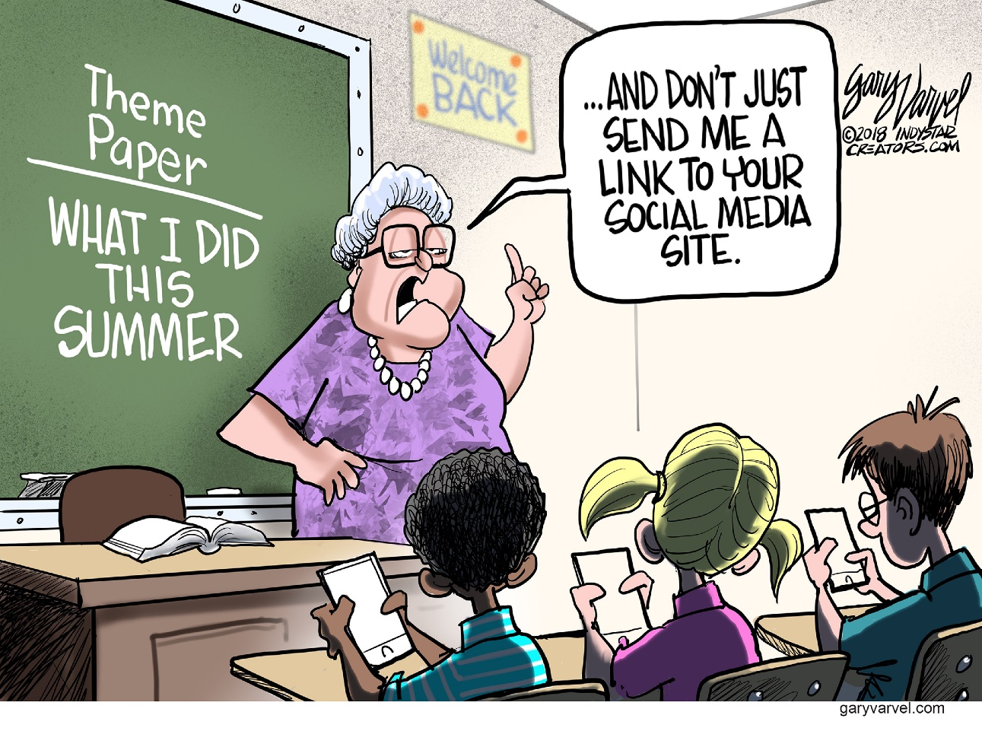  
source: https://theweek.com/cartoons

Zugriff am 15.04.2023

**III. Mediation (30%)**

**Situation:**

**You are interested in the fashion industry and you come across the following article which you find rather shocking. As the current topic in your English class is “The Impact of Globalization on the Environment” you start and prepare a little presentation.**

**You concentrate on the following aspects:**

* **You describe the situation in Jamestown (Accra).**
* **You describe the problems of the secondhand market for textiles in Kantamanto.**
* **You explain how the German minister Svenja Schulze wants to solve the problem.**

|  |  |  |
| --- | --- | --- |
| **FO G/T/W 21 GTA 21** | **BBS Neustadt a. Rbge.** | **Name:** |
| **15.05.2023** | **Abschlussprüfung Englisch** | **Vorschlag B** |

**„Wir versinken im Müll, wir werden alle krank“**

**Die Minister Heil und Schulze besuchen in Ghana den größtenTextil-Secondhandmarkt der Welt – der immer mehr zur Müllhalde wird**

Von Tim Szent-Ivanyi

**Accra.**Es stinkt zum Himmel, die Luft ist ätzend. Müllberge, die vor sich hin qualmen, türmen sich bis zu 30 Meter hoch. Gleich daneben stehen die Hütten der Anwohner. Die Wasseroberfläche eines Flusses, der keine 500 Meter weiter ins Meer fließt, ist komplett unter einer dicken Schicht Lumpen verschwunden. Durch das Wasser waten Menschen, die die Abfälle durchsuchen. Der Chef der anliegenden Gemeinde, in der viele Fischer leben, berichtet von Infektionen, Vergiftungen und Hautkrankheiten. Fische gebe es im Fluss schon lange nicht mehr, erzählt er.

Willkommen im Stadtteil Jamestown der ghanaischen Hauptstadt Accra. Willkommen an der Endstation von Fast Fashion. Wer wissen möchte, wo seine nur wenige Wochen getragenen T-Shirts, Kleider oder Hosen von Primark, Sheine und Co. landen, ist hier richtig.

„Furchtbar, einfach nur furchtbar“, entfährt es Svenja Schulze beim Blick auf die riesigen Lumpenberge. Kopfschüttelnd stapft die Entwicklungsministerin zusammen mit Arbeitsminister Hubertus Heil (beide SPD) durch den Müll und lässt sich vom Gemeindevorsteher Bernard die Situation erklären. Niemand kümmere sich um diese Umweltkatastrophe, klagt er.

Wenig später stehen die beiden Minister dort, wo die internationale Textilkreislaufwirtschaft zumindest auf den ersten Blick noch funktioniert: Im Stadtteil Kantamanto befindet sich der größte Textil-Secondhandmarkt der Welt. Täglich kommen hier tonnenweise Alttextilien aus der westlichen Welt an, die Rede ist von 15 Millionen Kleidungsstücken pro Woche. Ghana ist der größte Importeur von Alttextilien – und Deutschland einer der Hauptexporteure.

Auf dem Markt von Kantamanto sind rund 30 000 Menschen damit beschäftigt, die getragene Kleidung zu sortieren, zu reinigen, aufzuarbeiten und weiterzuverkaufen. Der Markt ist ein mehrere Fußballfelder großes Areal. So geschickt die Schneiderinnen auch sein mögen, die Kreislaufwirtschaft von Textilien funktioniert nicht mehr richtig. Das liegt nicht nur an den kaum noch beherrschbaren Mengen, die in Accra landen, sondern insbesondere an der Qualität der Kleidung. Waren es früher eher haltbare Textilien aus Baumwolle, erreicht nun vermehrt billige Fast Fashion aus Kunstfaser- oder Mischgeweben den Markt. Liz Rickett von der US-Hilfsorganisation OR-Foundation, die sich um Textilarbeiter kümmert, berichtet, dass diese Entwicklung zwei negative Effekte hat: Zum einen verdienten die Menschen weniger, weil sich gebrauchte Fast Fashion nicht gut weiterverarbeiten lasse. Zum anderen werde ein massives Umweltproblem verursacht, weil nicht verwertbare Ware auf wilden Müllkippen entsorgt werde und der Plastikabfall dann im Meer lande. Nach Schätzungen liegt der Anteil der in Kantamanto aussortierten Textilien bei bis zu 40 Prozent.

In Europa laufen Bemühungen, die Textilmüllflut einzudämmen. Bei der geplanten EU-Lieferkettenrichtlinie soll auch der „Down­stream“ geregelt werden, also der weitere Weg eines Produktes nach dem Gebrauch. Innerhalb der „Textilstrategie“ wird in der EU daran gearbeitet, mit konkreten Vorgaben dafür zu sorgen, dass Produkte langlebiger werden und sich besser recyceln lassen. Außerdem hat die EU-Kommission vorgeschlagen, die Hersteller an Entsorgung und Recycling zu beteiligen.

Eine bestimmte Lösung lehnt Ministerin Schulze ab: den Textilexport schlicht zu verbieten. Denn damit würden Zehntausende Menschen in Ghana ihren Job verlieren. Vielmehr plädiert sie dafür, durch eine europäische Regulierung besser abzugrenzen, was noch ein Secondhand-Rohstoff ist und was nur noch Müll, der in Europa entsorgt werden muss. Zudem sei der Aufbau von Recyclingkapazitäten in Afrika selbst Teil der Lösung, sagt sie und kündigt von Deutschland geförderte Pilotprojekte an. „Damit können in der Textilwirtschaft in Afrika grüne Arbeitsplätze geschaffen werden“, gibt sie sich optimistisch.

Der Chef des von der Öko­ka­ta­strophe betroffenen Stadtteils benötigt jedoch schnellere Lösungen: „Wir versinken im Müll, wir werden alle krank.“

*Quellenangabe: HAZ vom 23.02.2023, Seite 11*