**Hinweise zur Bearbeitung:**

* **Bitte lasse rechts einen Rand von 5cm.**
* **Erlaubte Hilfsmittel: Zweisprachiges Wörterbuch**

**I. Reception - Reading Comprehension (30%)**

**Greta Thunberg's Speech At The U.N. Climate Action Summit**

My message is that we'll be watching you.

**(A)** This is all wrong. I shouldn't be up here. I should be back in school on the other side of the ocean. Yet you all come to us young people for hope. How dare you! You have stolen my dreams and my childhood with your empty words. And yet I'm one of the lucky ones. People are suffering. People are dying. Entire ecosystems are collapsing.

**(B)** We are in the beginning of a mass extinction, and all you can talk about is money and fairy tales of eternal economic growth. How dare you! For more than 30 years, the science has been crystal clear. How dare you continue to look away and come here saying that you're doing enough, when the politics and solutions needed are still nowhere in sight.

**(C)** You say you hear us and that you understand the urgency. But no matter how sad and angry I am, I do not want to believe that. Because if you really understood the situation and still kept on failing to act, then you would be evil. And that I refuse to believe.

**(D)** The popular idea of cutting our emissions in half in 10 years only gives us a 50% chance of staying below 1.5 degrees [Celsius], and the risk of setting off irreversible chain reactions beyond human control. Fifty percent may be acceptable to you. But those numbers do not include tipping points, most feedback loops, additional warming hidden by toxic air pollution or the aspects of equity and climate justice. They also rely on my generation sucking hundreds of billions of tons of your CO2 out of the air with technologies that barely exist. So a 50% risk is simply not acceptable to us — we who have to live with the consequences.

**(E)** To have a 67% chance of staying below a 1.5 degrees global temperature rise – the best odds given by the [Intergovernmental Panel on Climate Change] – the world had 420 gigatons of CO2 left to emit back on Jan. 1st, 2018. Today that figure is already down to less than 350 gigatons.

**(F)** How dare you pretend that this can be solved with just 'business as usual' and some technical solutions? With today's emissions levels, that remaining CO2 budget will be entirely gone within less than eight and a half years. There will not be any solutions or plans presented in line with these figures here today, because these numbers are too uncomfortable. And you are still not mature enough to tell it like it is.

**(G)** You are failing us. But the young people are starting to understand your betrayal. The eyes of all future generations are upon you. And if you choose to fail us, I say: We will never forgive you. We will not let you get away with this. Right here, right now is where we draw the line. The world is waking up. And change is coming, whether you like it or not.

Thank you.

Source: <https://www.nbcnews.com/news/world/read-greta-thunberg-s-full-speech-united-nations-climate-action-n1057861>, last visited 04 November 2021.

**Annotations**:

l. 3 dare – wagen

l. 4 suffer – leiden

l. 6 mass extinction – Massenausrottung

l. 7 eternal – ewig

l. 11 fail – versagen

l. 14 irreversible – unumkehrbar

l. 15 tipping points – Trendwende

l. 16 equity – Gerechtigkeit

l. 20 odds – Chancen

l. 23 pretend – vorgeben

l. 26 mature – reif

l. 28 betrayal – Betrug

**Task 1: Decide whether the following statements are true of false. If one is false, correct it. (___/10)**

|  |  |  |  |
| --- | --- | --- | --- |
|  | **Statement** | **true** | **false** |
| 1 | Greta names attendees of the UN Climate Action Summit liars.  *Correction*: ___________________________________________________  _____________________________________________________________ |  |  |
| 2 | People, animals and ecosystems will become extinct in a few years.  *Correction*: ___________________________________________________  _____________________________________________________________ |  |  |
| 3 | Greta believes in good.  *Correction*: ___________________________________________________  _____________________________________________________________ |  |  |
| 4 | Equity and justice are considered in cutting emission goals.  *Correction*: ___________________________________________________  _____________________________________________________________ |  |  |
| 5 | Young generations are made responsible to achieve the climate goals.  *Correction*: ___________________________________________________  _____________________________________________________________ |  |  |
| 6 | Politicians turn a blind eye on the amount of produced emissions.  *Correction*: ___________________________________________________  _____________________________________________________________ |  |  |
| 7 | Greta claims that the young generation’s limit has already been exceeded.  *Correction*: ___________________________________________________  _____________________________________________________________ |  |  |

**Task 2: Match the headings 1 - 9 to the paragraphs (A) – (G). There are three more headings than needed.**

1. inactivity **(___/7)**
2. danger
3. responsibility

|  |  |  |  |  |  |  |
| --- | --- | --- | --- | --- | --- | --- |
| (A) | (B) | (C) | (D) | (E) | (F) | (G) |
|  |  |  |  |  |  |  |

1. success
2. warning
3. trust
4. hope
5. despair
6. failure

**II. Production – Cartoon Analysis (40%)**

**Task: Describe, analyze and evaluate the cartoon.**

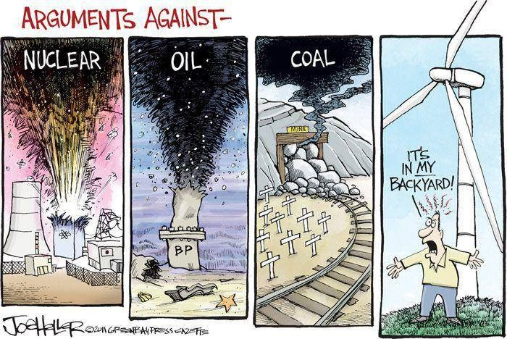

Source: Joe Haller, <https://www.englishblog.com>, 30 March 2011, last visited 04 November 2021.

**III. Essay (30%)**

**Globalization is a blessing for mankind. Discuss!**

**I Reading**

**Task 1**

|  |  |  |  |
| --- | --- | --- | --- |
|  | **Statement** | **true** | **false** |
| 1 | Greta names attendees of the UN Climate Action Summit liars.  *Correction*: ___________________________________________________  _____________________________________________________________ | X |  |
| 2 | People, animals and ecosystems will become extinct in a few years.  *Correction*: are already extinct; we are at the beginning of a mass extinction |  | X |
| 3 | Greta believes in good.  *Correction*: ___________________________________________________  _____________________________________________________________ | X |  |
| 4 | Equity and justice are considered in cutting emission goals.  *Correction*: numbers (aim of 1.5) don’t include equity and climate justice |  | X |
| 5 | Young generations are made responsible to achieve the climate goals.  *Correction*: ___________________________________________________  _____________________________________________________________ | X |  |
| 6 | Politicians turn a blind eye on the amount of produced emissions.  *Correction*: ___________________________________________________  _____________________________________________________________ | X |  |
| 7 | Greta claims that the young generation’s limit has already been exceeded.  *Correction*: The line (limit) is drawn at the climate summit |  | X |

**Task 2**

|  |  |  |  |  |  |  |
| --- | --- | --- | --- | --- | --- | --- |
| (A) | (B) | (C) | (D) | (E) | (F) | (G) |
| 8 | 2 | 6 | 3 | 9 | 1 | 5 |

**II Cartoon (11 Punkte)**

Introduction:

* Source + topic
  + Source: cartoonist Joe Haller, website [www.englishblog.com](http://www.englishblog.com), 20 March 2011. (1)
  + Topic: arguments against different methods of gaining energy (1)

Description

* Headline: ‘alternative against’ (0,5)
* Devided into four pictures showing different methods of gaining energy (from left to right: nuclear, oil, coal, wind mills) (0,5)
* Nuclear power plant is exploding (0,5)
* underwater oil pipeline is broken, and oil is leaking into the ocean (0,5)
* coal mine is blocked by several big stones, next to the railway are several crosses (0,5)
* all three have in common that black ‘clowds’ darken the upper part of the picture (0,5)
* man, looking frustrated, standing in front of a windmill and shouting ‘not in my backyard’ (1)

Analysis

* three conventional energy sources, one alternative energy source (1)
* black ‘clouds’ of conventional energy sources symbolize danger/pollution (1) for people and environment
* even for clean energy (wind mill) arguments against using are found (1) 🡪 it is ‘polluting’ the view (1)

Evaluation

* The cartoon is effective/well-made/easy to understand, because… (2)

**III Essay:**

**Introduction**

* Implementation of topic
* Own thesis concerning the topic

**Main part**

* two pro and two con arguments are expected 🡪 4 paragraphs
* in each discussed point (paragraph) some examples and/or evidence have to be presented

**Conclusion**

* briefly summarizing the 4 points discussed
* stating own opinion (has to match the thesis of the introduction)